Parallel Programming

CS575

Chao Zhang

Project #5

1. Source listing

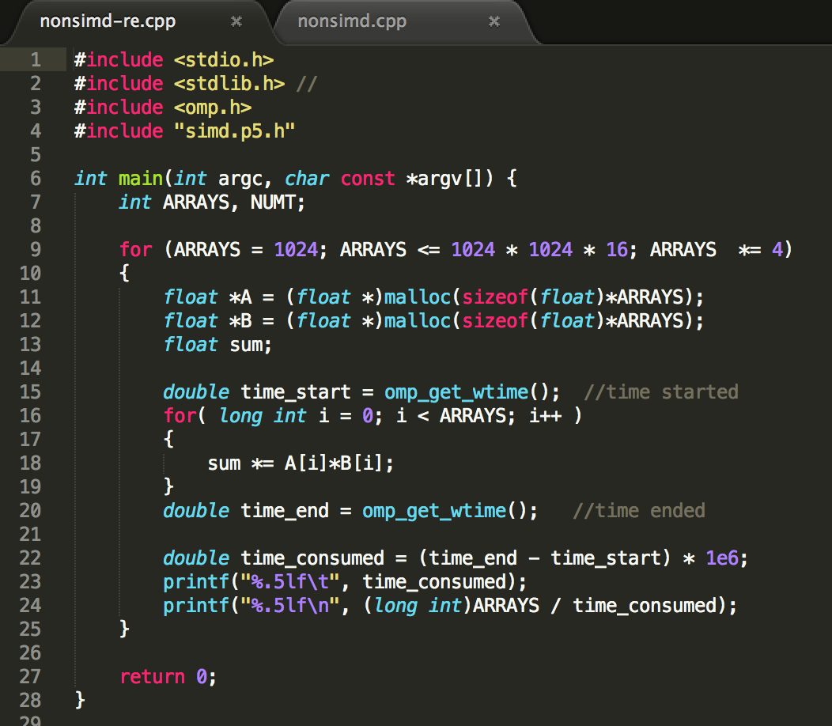

This is the code of non-simd and reduction. It calculates the sum of two array and print out the results so I can compare it with the simd and reduction’s results.

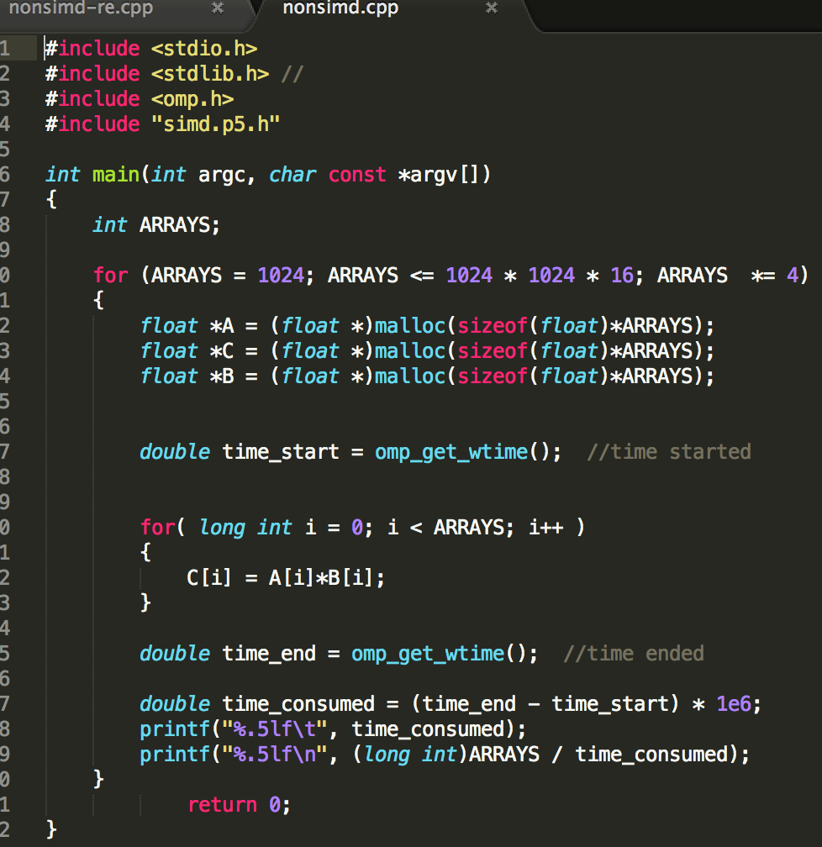

This is the code of non-simd. It calculates the sum of two array and print out the results so I can compare it with the simd results.

1. Result and analysis



compare result table

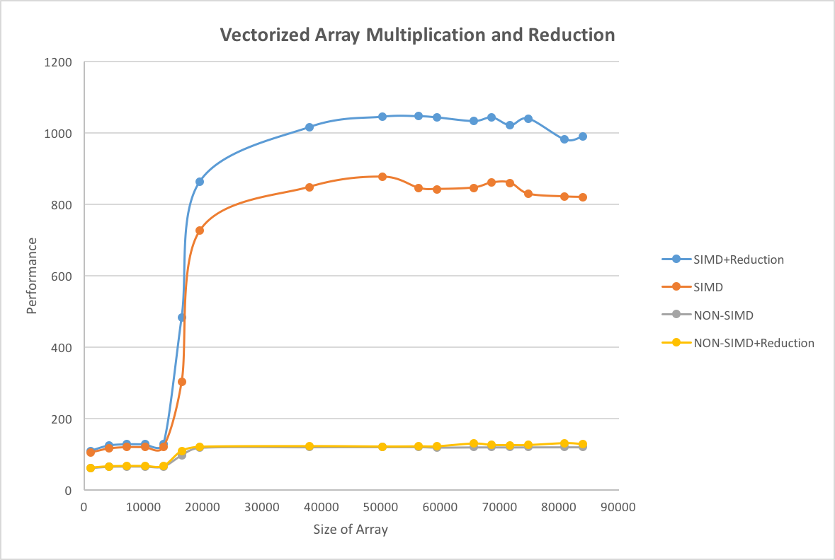

compare results Graph

In the beginning, those four lines of performances are very similar, I think this is because the array size is small, so even the effective calculate cannot better too much. After the array size bigger than 10000, the size is big enough to show the different between them. So the SIMD and SIMD+reduction much better than the other two, because the simd make the process of multiple-data operation in a single instruction. And the nonsimd and nonsimd+reduction already reach the limit. The simd+reduction is faster than the simd is because the reduction makes it more effective. I think the speed up is based on the flip can the hardware, those will make the speed up higher the 4.